**User Manual**

This section is intended to explain to the **User how to use our web application** by parts in order to have a better experience using the Genome Pro web application.

**Step 1:**

First, you will need two basic things, number **1** a device and number **2** a web browser:

**1**  **2** 

Then, you will be able to find the Genome Pro web application URL at: **http://genomepro.cis.fiu.edu**

**Step 2:**

Once you are in the Genome Pro web application you should see the main page:

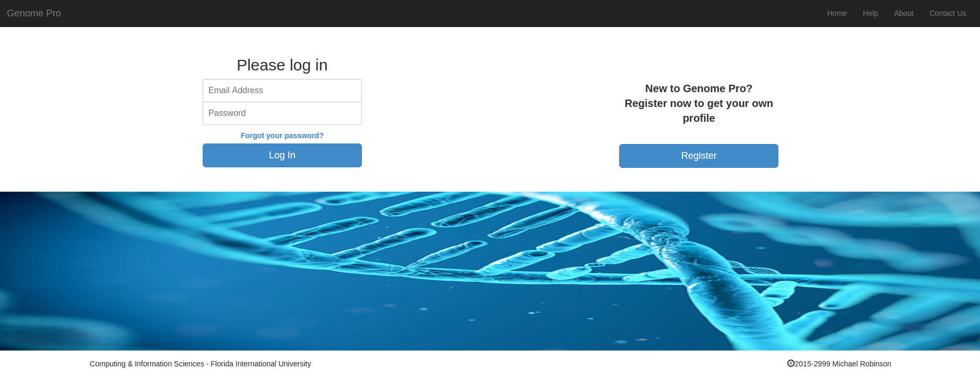

There you have two options **login into** the system if you already have a Genome Pro account or **register** if you are new to Genome Pro. Step 3 will guide you on how to **register**.

**Step 3:**

First, you need to click on the **blue button** that says **register** on the **main page**. Once you click it, you will see the registration page that looks like this:

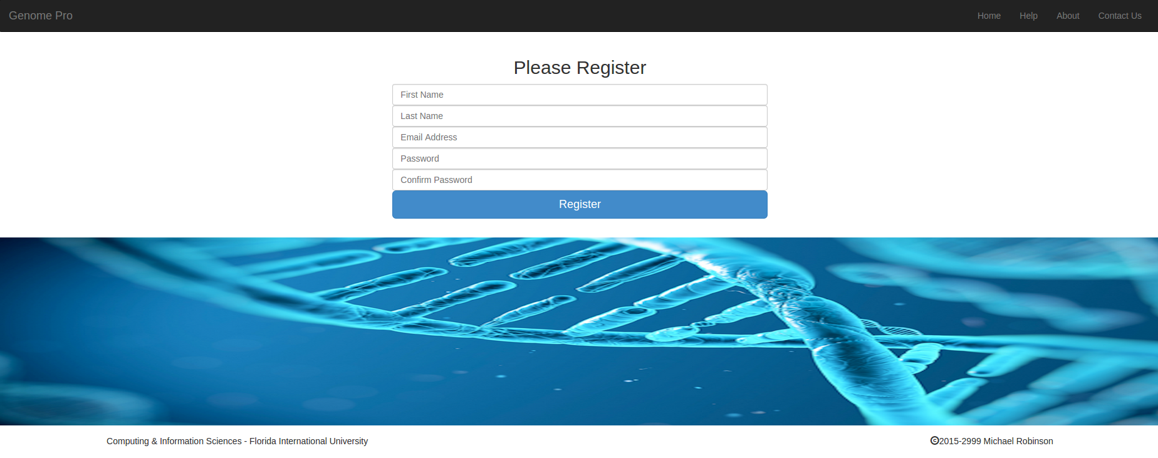

Then you will need to enter the corresponding information into the fields. You will need to enter your **First Name**, **Last Name**, **Email Address**, **Password**, and **Confirm Password**. Next you can click on the **blue button** that says **register**.

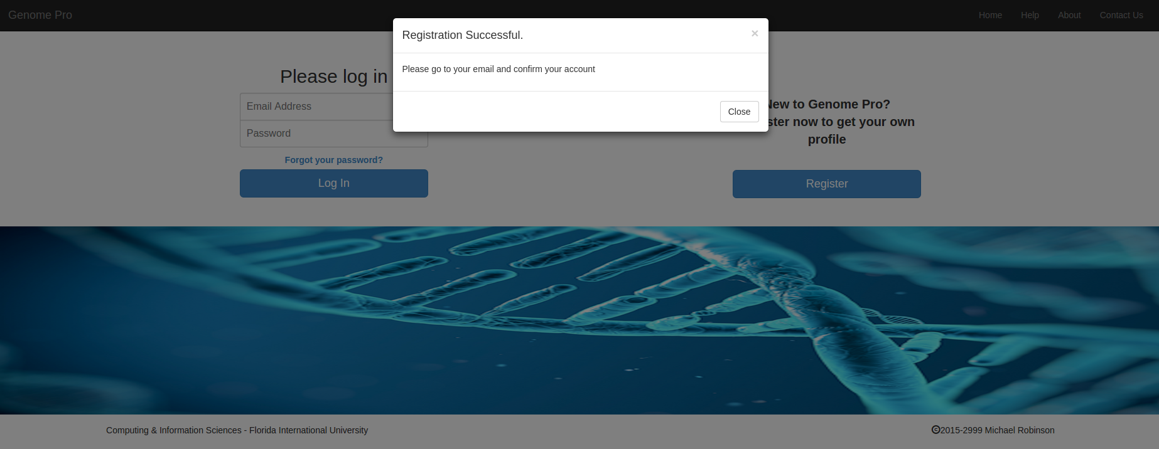

The system will automatically send you an **email confirmation** to the email you provided. To finish the registration process, you will need to **click on the link** that was sent to your email.

**Step 4:**

Step 4 will guide you how to **log into the system** if you already have an account. First, you will need to enter your **Email Address** and **Password** on the **main page**. Then you need to click in the **blue button** that says **Log in**. Once you click on **Login,** the system will redirect you to **your profile page** that will looks like this:

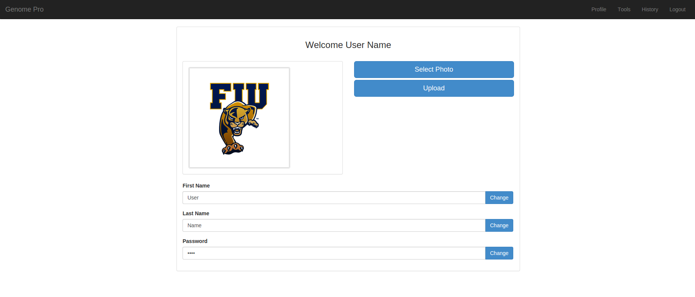

**Step 5:**

Step 5 will show you how to **recover your password** from the **main page** in case you lose it or forget it. You need to **click** in **Forgot your password link** located below the **Login** button. Once you **click it,** an **alert box** will appear that looks like the one **below**. The **alert box** will ask you to enter your **Email Address** in order to **recover your password** and then **click** on the recovery **button**. The system will send you an **email** with a **temporary password** in order for you to **log in into the system**, once you login **into your profile** you can change it.

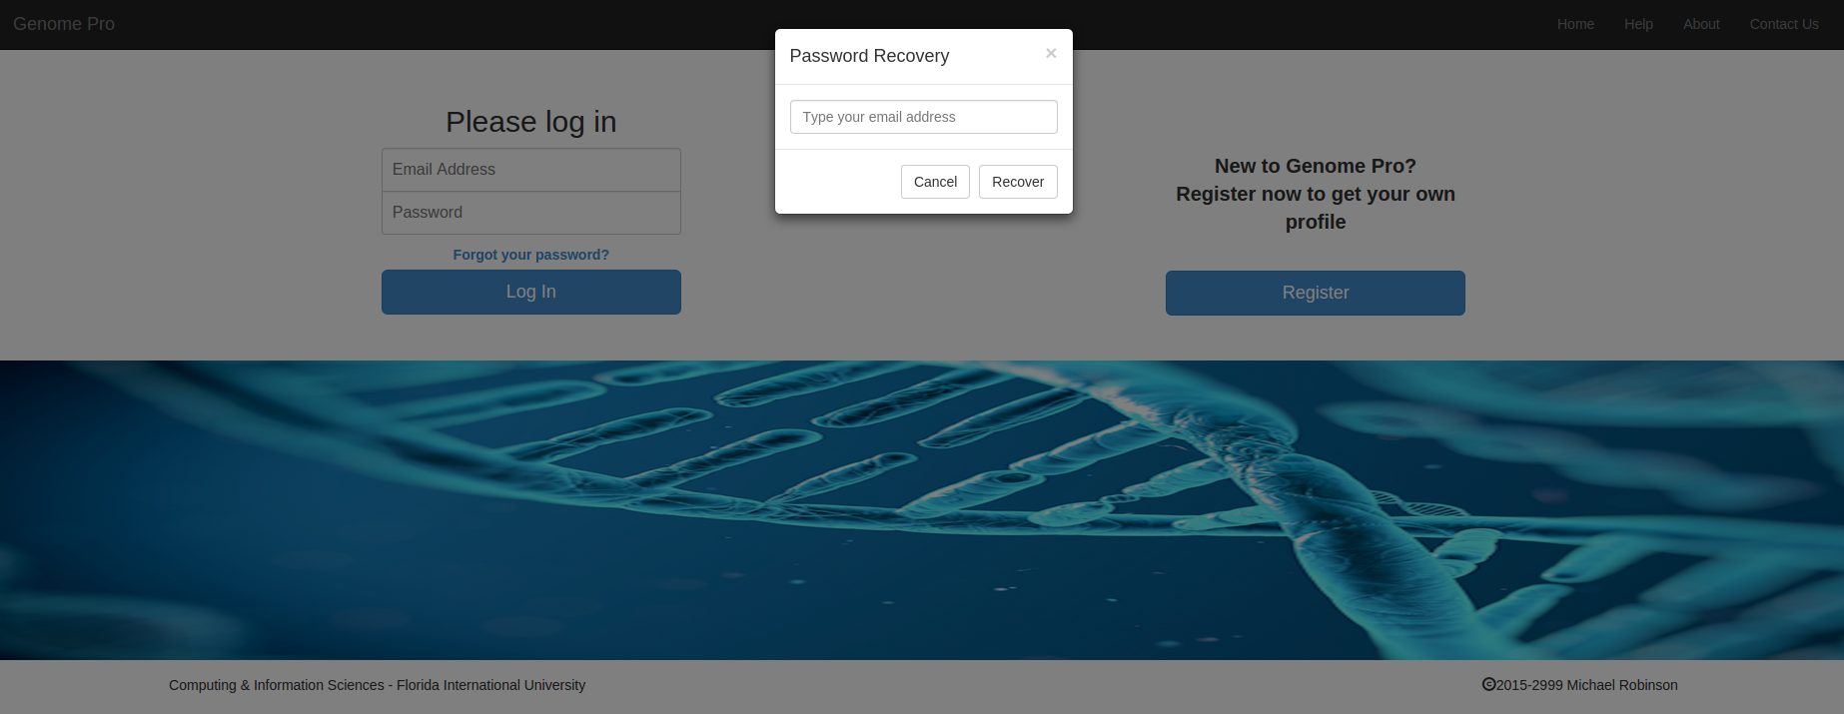

**Step 6:**

Step 6 will show you how to **Contact Us** for any issue or concern. On the **Main page or Homepage** on the menu bar you will see a **Contact Us** button **click on it**. Once that you click it will redirect you to the **Contact Us page** that look like this.

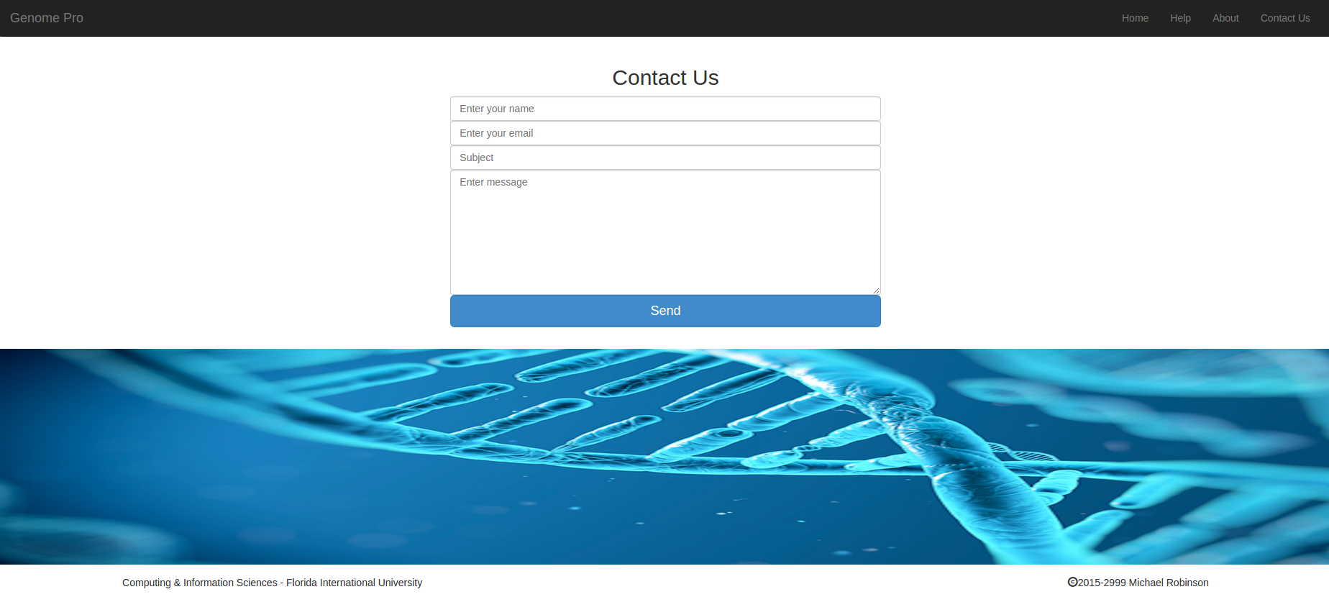

Then you will need to **fill out** the following information, **Your First Name or Full Name** preferible **Full Name** for a quickly search of the system, **Email**, **Subject**, **Message**, and then **click on Send**. The system will **popup a window** that look like below. This means that your message was sended to us.

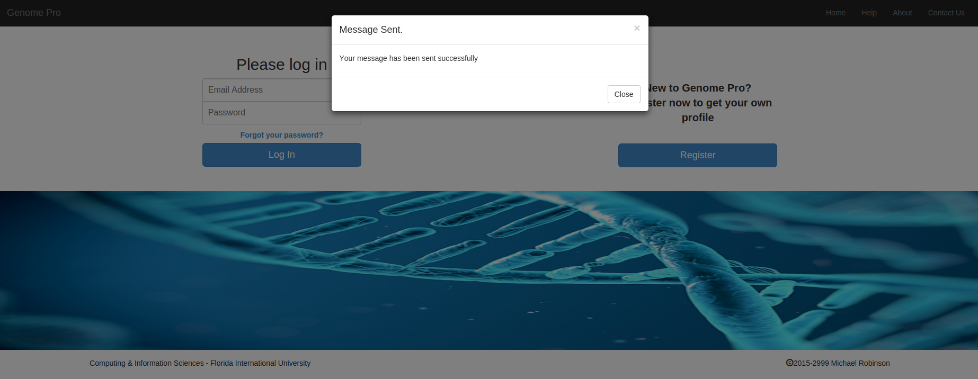

**Step 7:**

Step 7 will show you how to use the Genome Pro Tools to **upload and process genomic files** from your **Profile page**. First you will need to go to **Tools** located on the **Profile page** menu bar. You will see different **Tabs**. Each Tab have different applications, the instructions will be presented below the name of the application.

**TAB #1:**

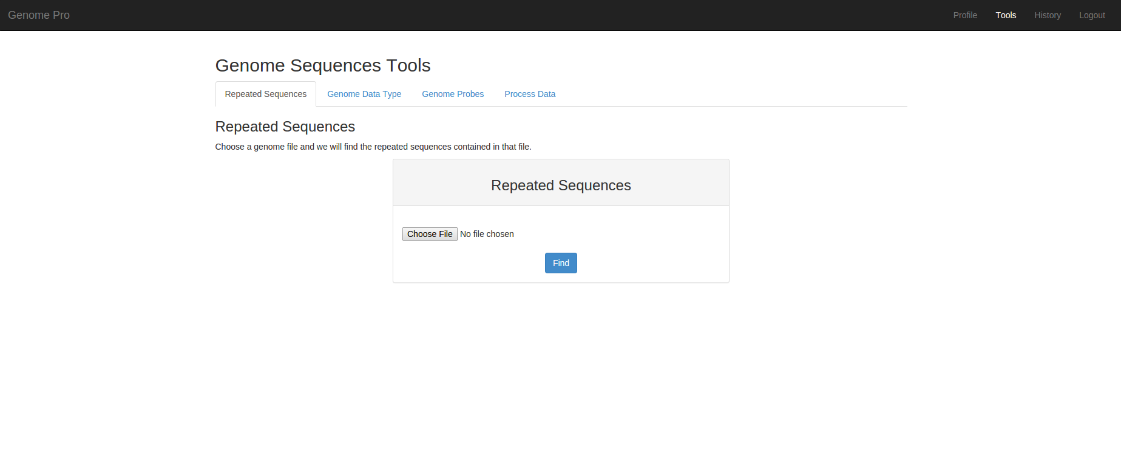

**TAB #2:**

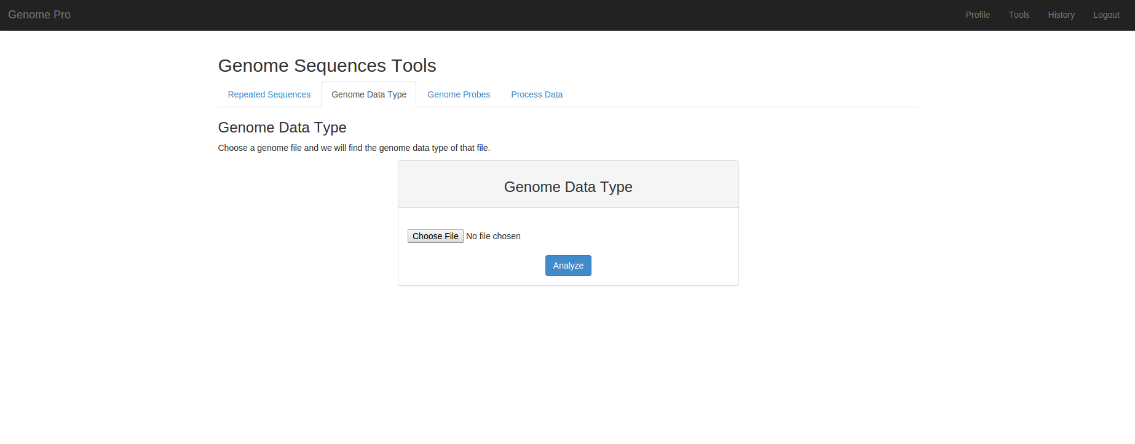

**TAB #3:**

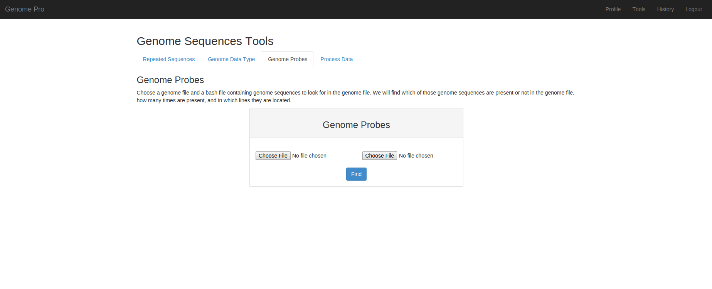

**TAB #4:**

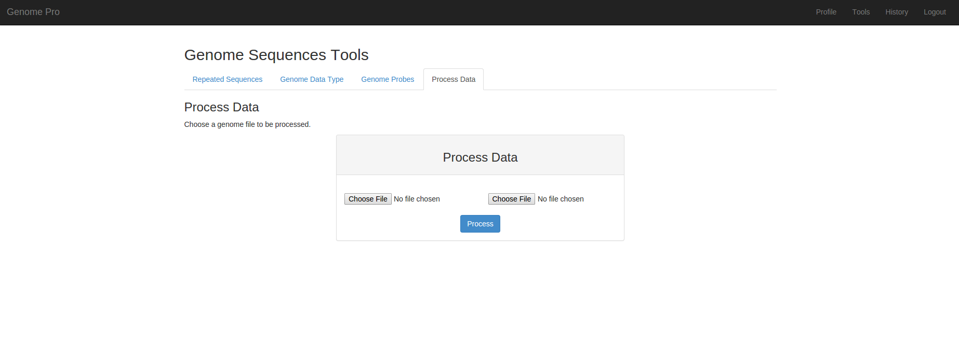

In order to **Upload and process genomic files** you will need to have the **files** ready for the system to process them. Once that you're ready you can go ahead and proceed to upload the files. Once you have finished uploading the files click in the **Blue Button** below each box. The System will **show a window** saying that the files have been uploaded correctly.

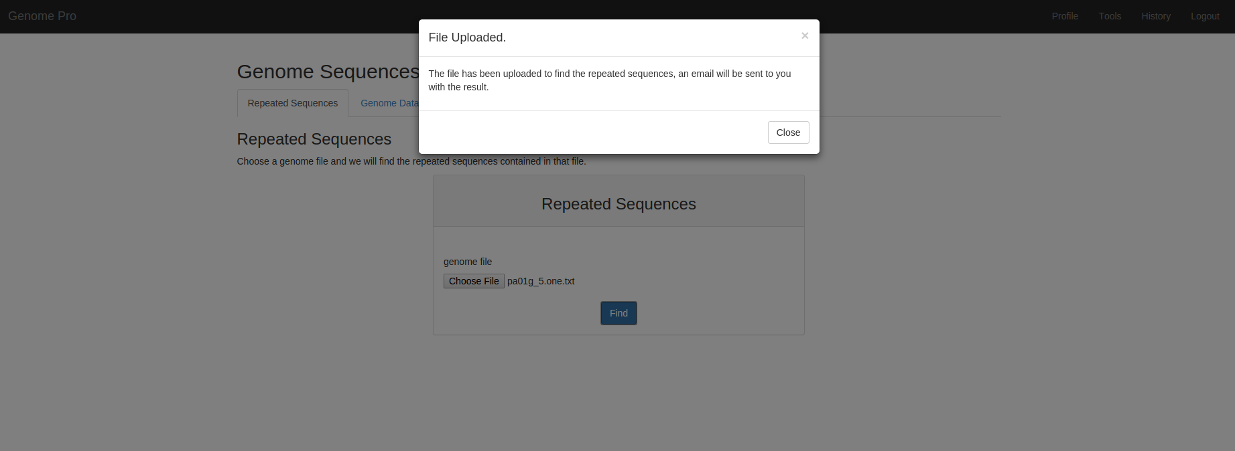

**Step 8:**

Step 8 will show you how to **see your files and results in History Page** from your **Profile page**. First you will need to go to **History** located on the **Profile page** menu bar. You will see differents **Tabs**. Each Tab contains the history for each one of the different tools. You will see your result by **clicking in the download button,** once you click it will download the file directly to **your system**.

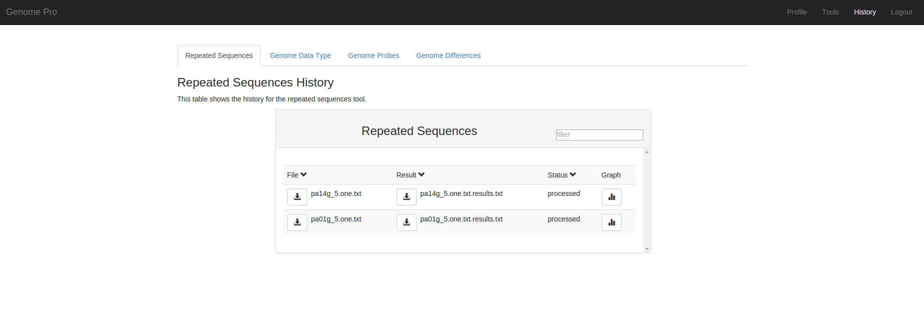

The repeated sequences history tab will allow you to see **your results** in a **graph** by clicking in a **graph icon**, the graph will look like this.

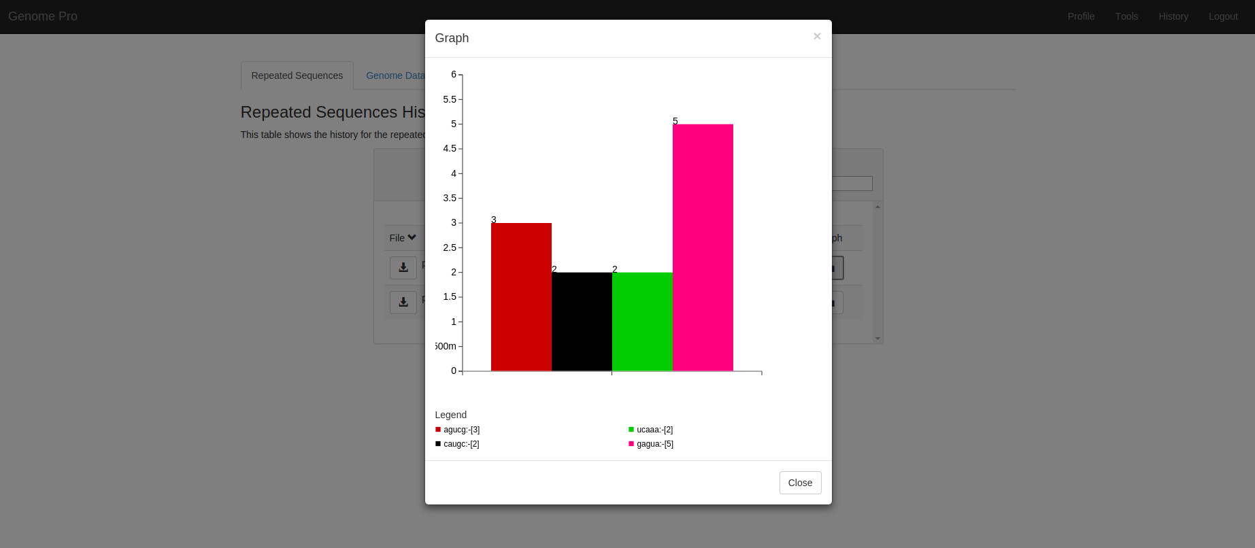

**Step 9:**

Step 9 will show you how to **change your personal information** in your **Profile page**. You will have **Four options** such as change **your profile picture,** change your **your name**, change your **last name**, and change your **password**. I will guide you by the order in which the options are displayed.



First, to change **your profile picture**, you need to click in the **Blue Button** that says **select photo**. Once you **click it,** you can **browse** for **your photo** in your system. Once you **choose your photo** you can go ahead and click in the **Blue Button** that says **Upload**. Once you Upload your photo the system will show you a message box that looks like this.

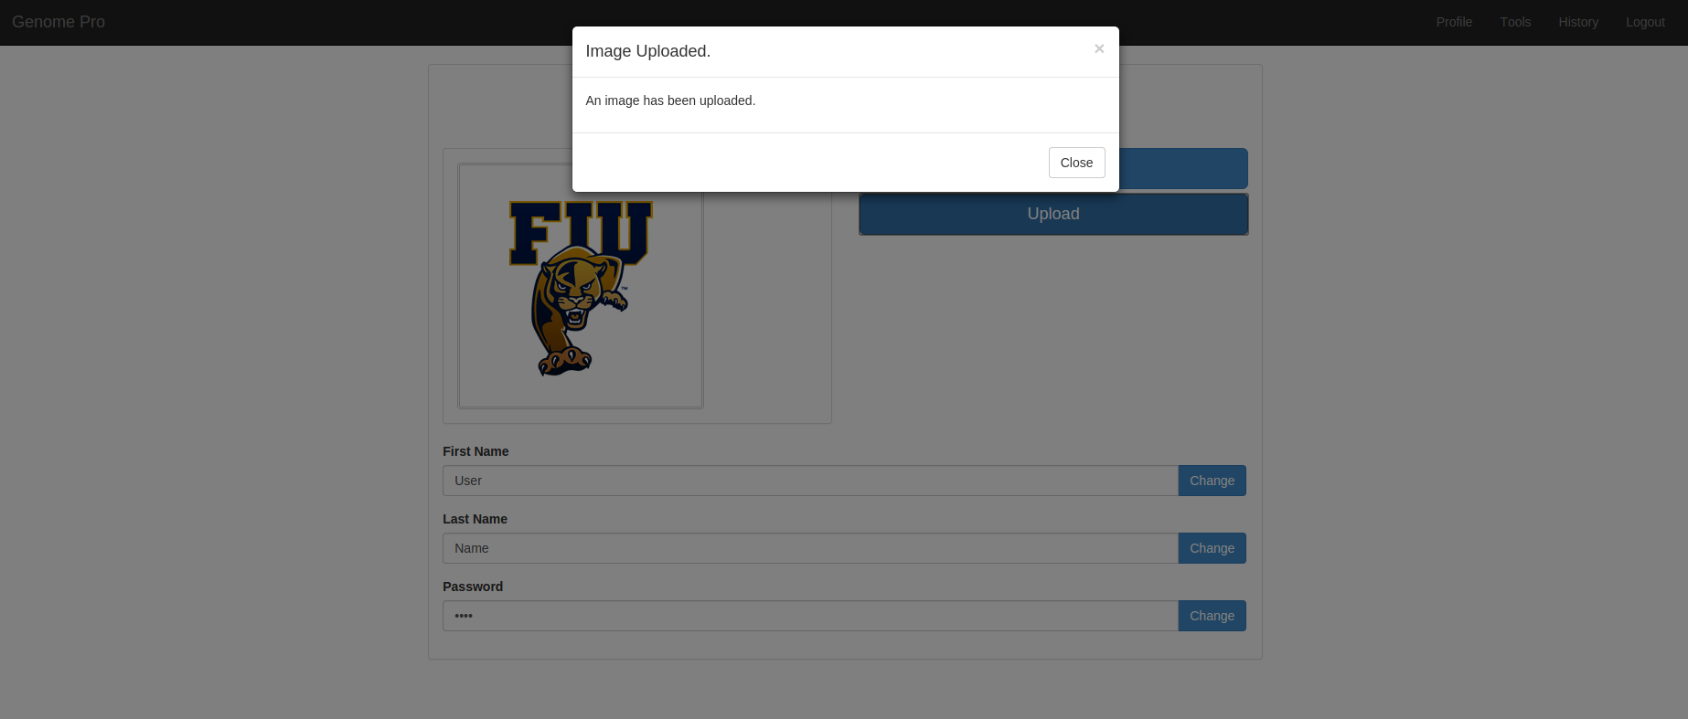

Second, to change **your first name**, you need to click in the **Blue Button** that says **change**. Once you click it, the system will **display** an **alert box** that look like this.

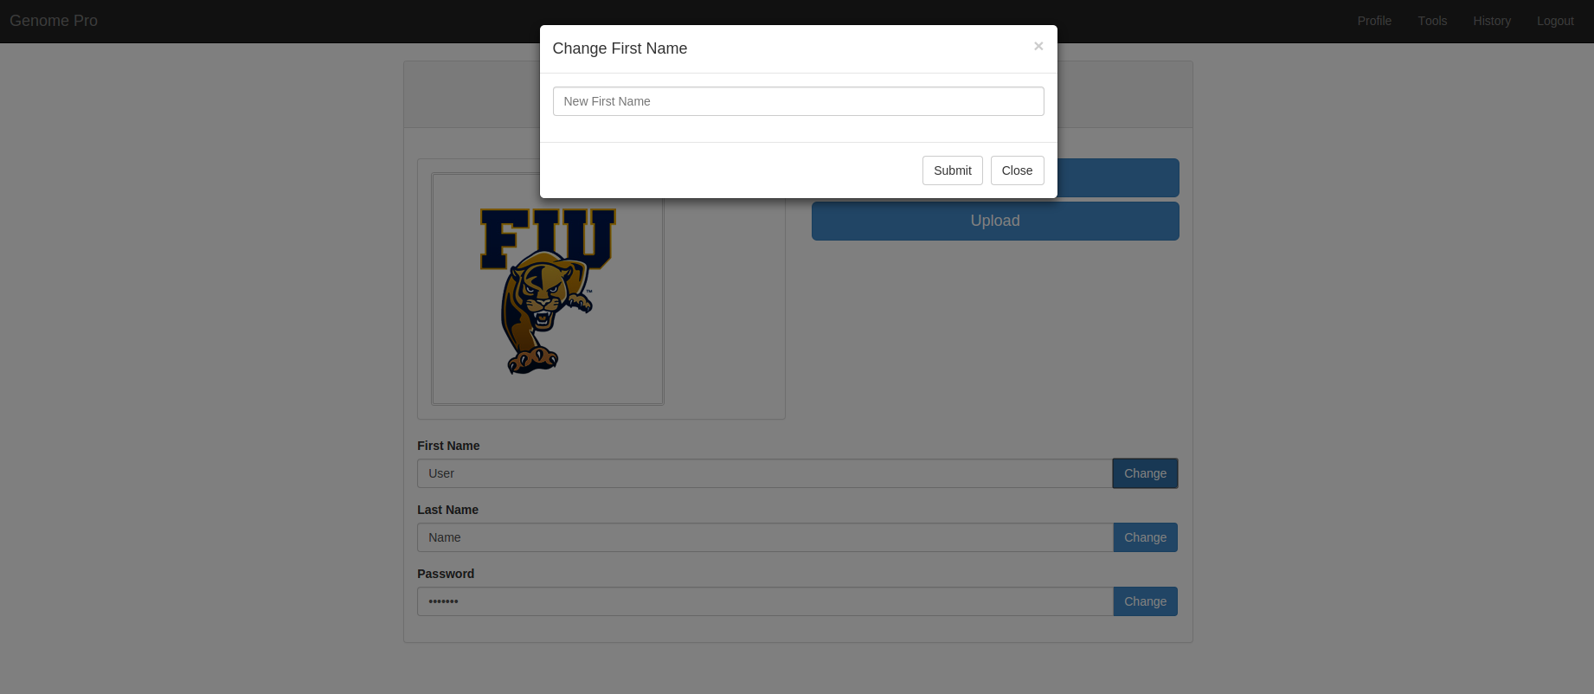

Once you submit, the system will show you a message box that look like this.

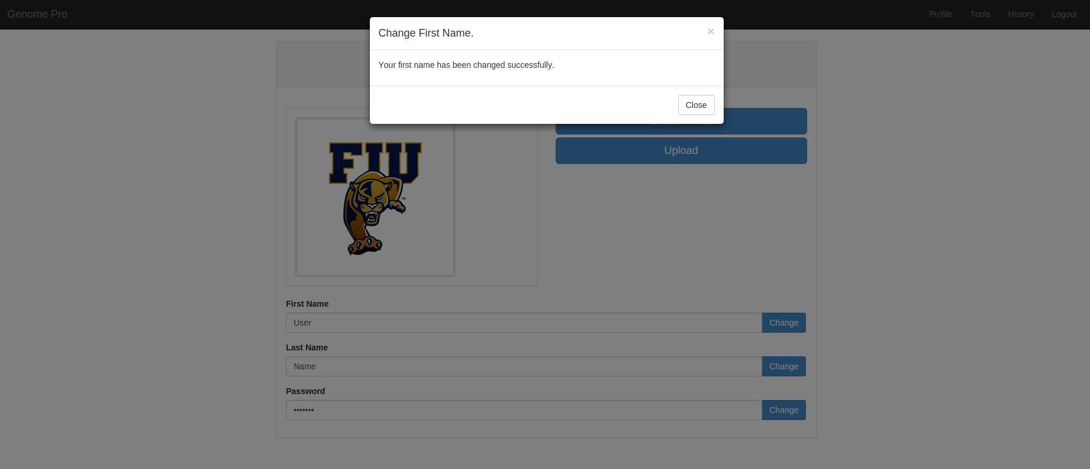

Third, to change **your last name**, you need to click in the **Blue Button** that says **change**. Once you click it, the system will **display** an **alert box** that look like this.

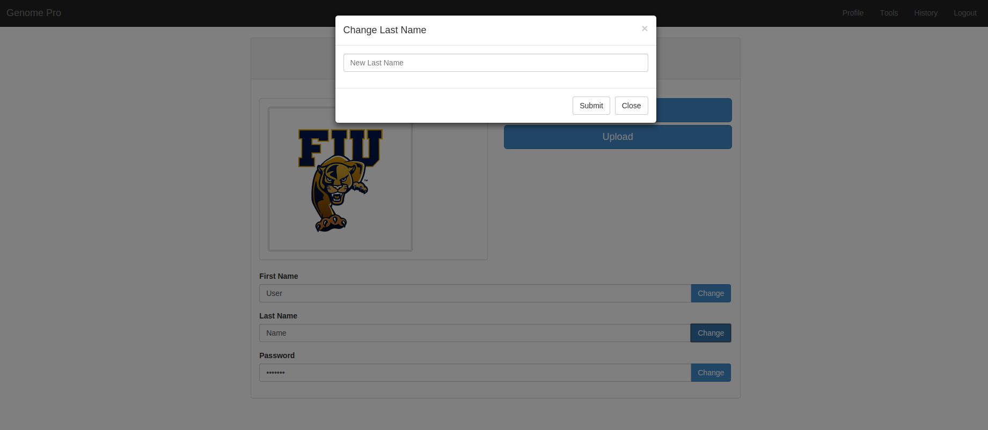

Once you submit, the system will show you a message box that look like this.

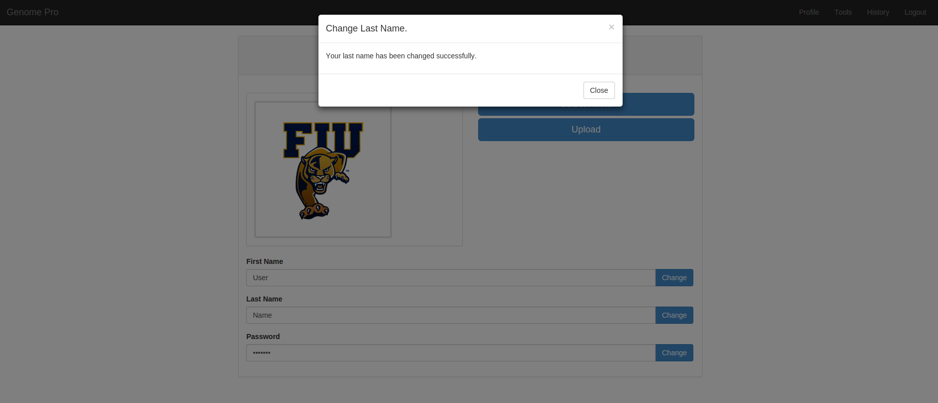

Fourth, to change **your password**, you need to click in the **Blue Button** that says **change**. Once you click it, the system will **display** an **alert box** that look like this.

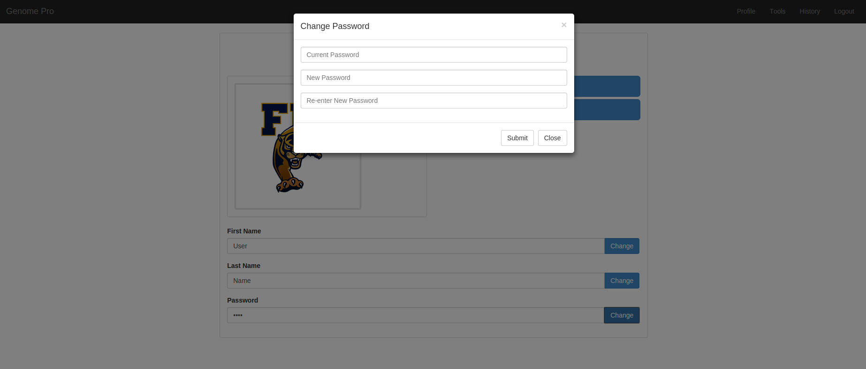

Once you submit, the system will show you a message box that look like this.

